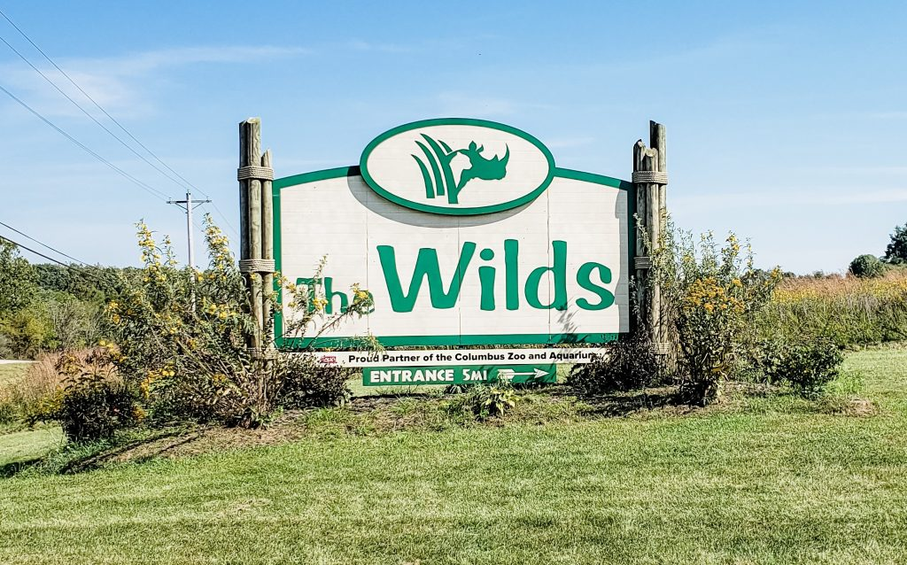

About Wild Zoo Park

What is Wild Park Zoo? and where is located established? The Wild park Zoo refers to various wildlife parks and zoos around the world that emphasize naturalistic enclosures, wildlife conservation, and often feature native species of their respective regions. However, without additional context, it's challenging to identify which specific "Wild park Zoo".

Opening & Closed Timings

Most zoos are open from 9:00 AM to 5:00 PM. These times can vary depending on the season, with extended hours in the summer and shorter days in the winter.

Some zoos might close on certain holidays or specific days of the week for maintenance, so it’s always a good idea to check in advance.

Some zoos might have special events like “Family Fun Days” or “Toddler Hours” in the morning when the zoo is less crowded, which is perfect for younger children. Interactive sessions like petting zoos, animal feeding times, or animal training demonstrations are common in the mornings, so arriving early can be a good idea.

Some zoos organize women’s events like early morning or evening walks where ladies can explore the zoo in a less crowded environment. Special group tours: Occasionally, there are women-only tours or workshops, especially focused on conservation efforts, animal care, or photography.

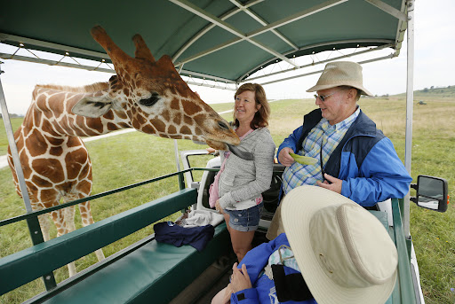

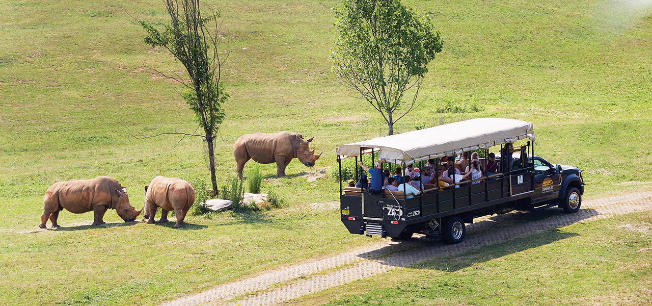

Animals List

In the United States, there isn't a zoo specifically named "Wild park Zoo."

Notable exhibits include:

Lions

Humboldt Penguin

tigers

Giraffe

Chapmans Zebra

White Rhinoceros

Sealions

Lizard

Monkeys

Address & Contact

Address: 16501 West Northern Avenue, Litchfield Park, AZ 85340. For questions related to visiting, opening times, directions, accessibility, or other general information, you can visit their [Support Centre](https://www.wildlifeworld.com).

Email: For specific enquiries

you can fill out the contact form available on their (information@thewilds.org.)

Phone: For urgent enquiries, you can call their Supporter Contact team at623-935-9453.

For the most accurate and up-to-date information, it's recommended to visit the [official wildlifeworld Zoo website](https://www.wildlifeworld.com/).